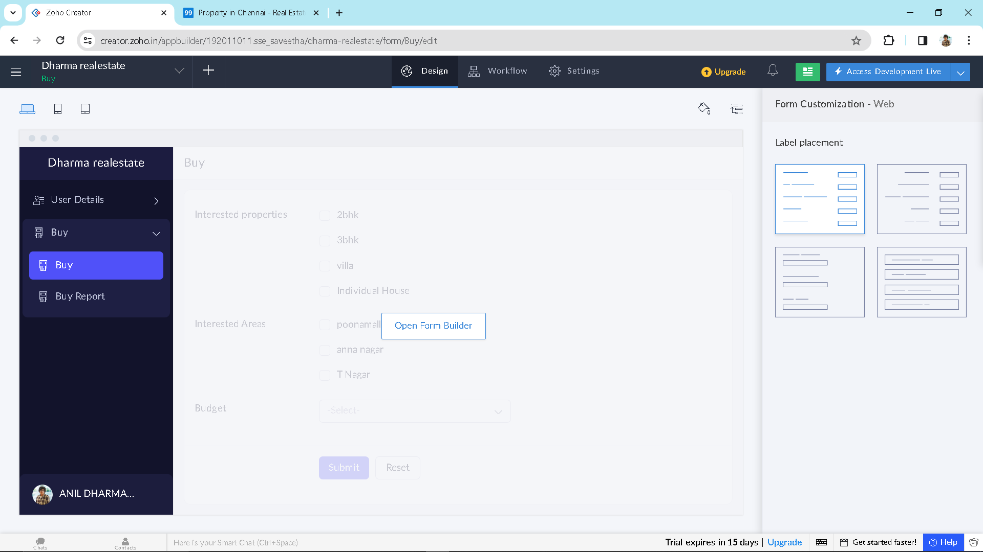

Step 1:Create your application

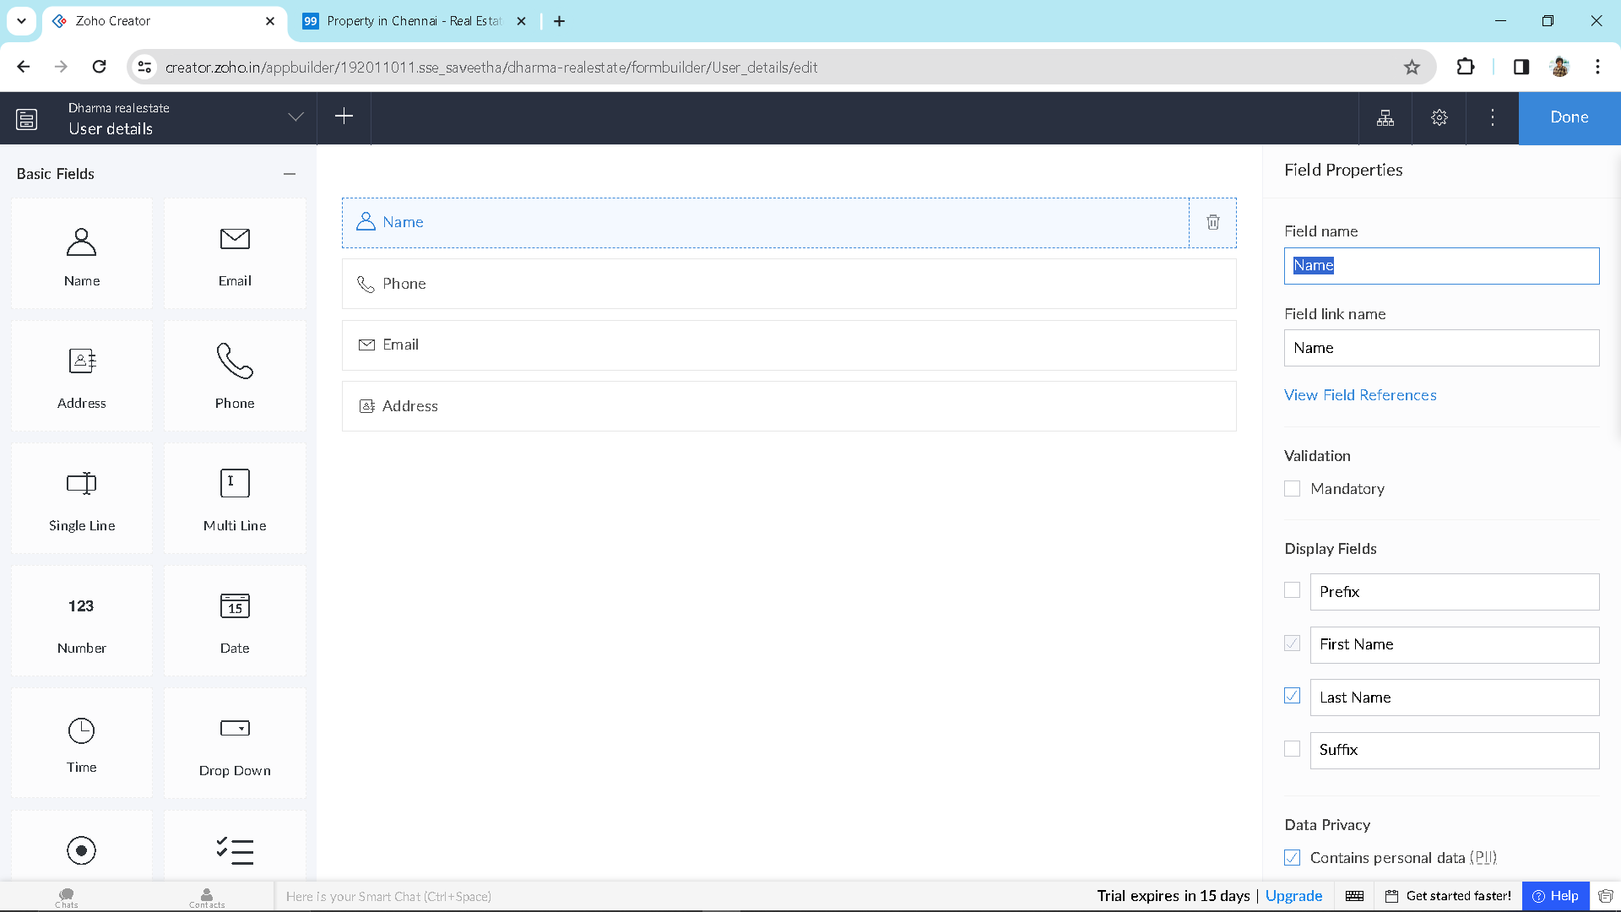

Step 2: Create forms for your application.

Step 3:This is the interface for the form you created



